EXPERIMENT 8
Objective
Different categories of employees are working in a software company like Regular Employees, Contract Employees and Vendors. And their pay roll is different for regular and contract employees. For the regular employees Basic pay is 25000, HRA is 15000rs and TA is 5000. For the Contract employees Basic pay is 12000 TA is 3000rs and there is no HRA. Find the monthly salary details of Employee. If input is Regular Employee display the Regular employee salary details. If input is Contract based display the Contract salary details. TestCase1: Input: Enter Employee Id: R101 Output: Salary Details: Basic Pay: 25000 HRA: 15000 T.A: 5000 Total Amount: 45000
Algorithm
• Start
• Import the Scanner class and create a Scanner object to take input from the user.
• Ask the user to enter the Employee ID.
• Read the Employee ID.
• Check the first character of the Employee ID:
- If it starts with R/r, treat it as a Regular Employee.
- If it starts with C/c, treat it as a Contract Employee.
- If it starts with V/v, treat it as a Vendor.
- Otherwise, display Invalid Employee ID.
• For a Regular Employee:
- Basic Pay = ₹25,000
- HRA = ₹15,000
- TA = ₹5,000
- Calculate:
Total Amount = Basic Pay + HRA + TA
- Display all salary details.
• For a Contract Employee:
- Basic Pay = ₹12,000
- TA = ₹3,000
- Calculate:
Total Amount = Basic Pay + TA
- Display the salary details.
• For a Vendor:
- Display the message:
"Vendors do not have a monthly fixed payroll."
• For an invalid Employee ID, display:
"Invalid Employee ID! Please start with R, C, or V."
• Close the Scanner object.
• Stop.
Code
package record;
import java.util.Scanner;
public class Experiment8 {
public static void main(String[] args) {
Scanner scanner = new Scanner(System.in);
// 1. Take input from the user
System.out.print("Enter Employee Id: ");
String empId = scanner.next();
// 2. Check the first letter of the Employee ID
if (empId.startsWith("R") || empId.startsWith("r")) {
// Regular Employee Calculation
int basicPay = 25000;
int hra = 15000;
int ta = 5000;
int totalAmount = basicPay + hra + ta;
// Display Results
System.out.println("Salary Details:");
System.out.println("Basic Pay: " + basicPay);
System.out.println("HRA: " + hra);
System.out.println("T.A: " + ta);
System.out.println("Total Amount: " + totalAmount);
} else if (empId.startsWith("C") || empId.startsWith("c")) {
// Contract Employee Calculation
int basicPay = 12000;
int ta = 3000;
int totalAmount = basicPay + ta;
// Display Results
System.out.println("Salary Details:");
System.out.println("Basic Pay: " + basicPay);
System.out.println("T.A: " + ta);
System.out.println("Total Amount: " + totalAmount);
} else if (empId.startsWith("V") || empId.startsWith("v")) {
// Vendor handling
System.out.println("Vendors do not have a monthly fixed payroll.");
} else {
// Invalid ID handling
System.out.println("Invalid Employee ID! Please start with R, C, or V.");
}
scanner.close();
}
}

UML Diagram
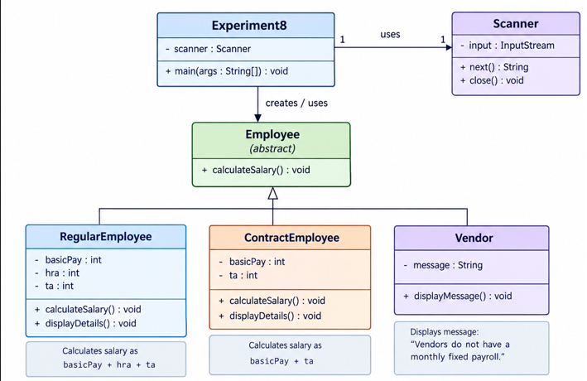
Output
